

**New-Zealand Masters Games Cycling 2020**

**Road Time Trial – Saturday 1st February**

**Report To:**

Outram Rugby Club

Formby St, Outram.

Report by 10.30 a.m. First Rider to start by 11.00 a.m.

There will be 1 minute intervals between riders.

Riders will be doing a 25km course (approx). 12.5km out and return.

Starting on Huntly Rd (near Crn of Formby St) and head towards Berwick (Southerly direction), turn around at bottom of Berwick Hill. Flat course with minimal undulations.

Medal presentations will follow the completion of racing.

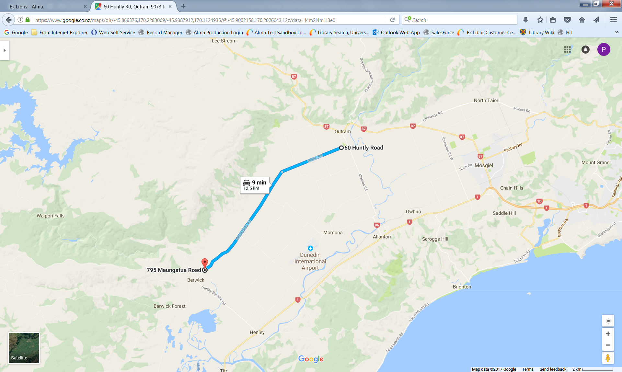

**Road Race - Sunday 2nd February**

**Report To:**

Henley Community Hall

Centre Road

Henley.

Registration by 10.30 a.m.

**Circuit is:**

Start in Centre Road, head North, Left into Otakia West Road, Left into Maungatua Road, Left into Berwick/Henley Road, Left into Centre Road, 400 metres to the finish. Circuit is 18.2kms.

4 laps for mens age groups up to 49, 3 laps for men 50+ and Womens age groups up to 69, 2 laps for men and women 70+.

All races will be on the circuit at the same time. There could be different age groups in the same bunches. Dependant on entries as to the size and numbers of bunches.

Prize giving will be at the Henley Hall after all races are complete. Please be aware that this venue is approx 5kms away from the nearest food store / petrol station. There are toilets available on site.

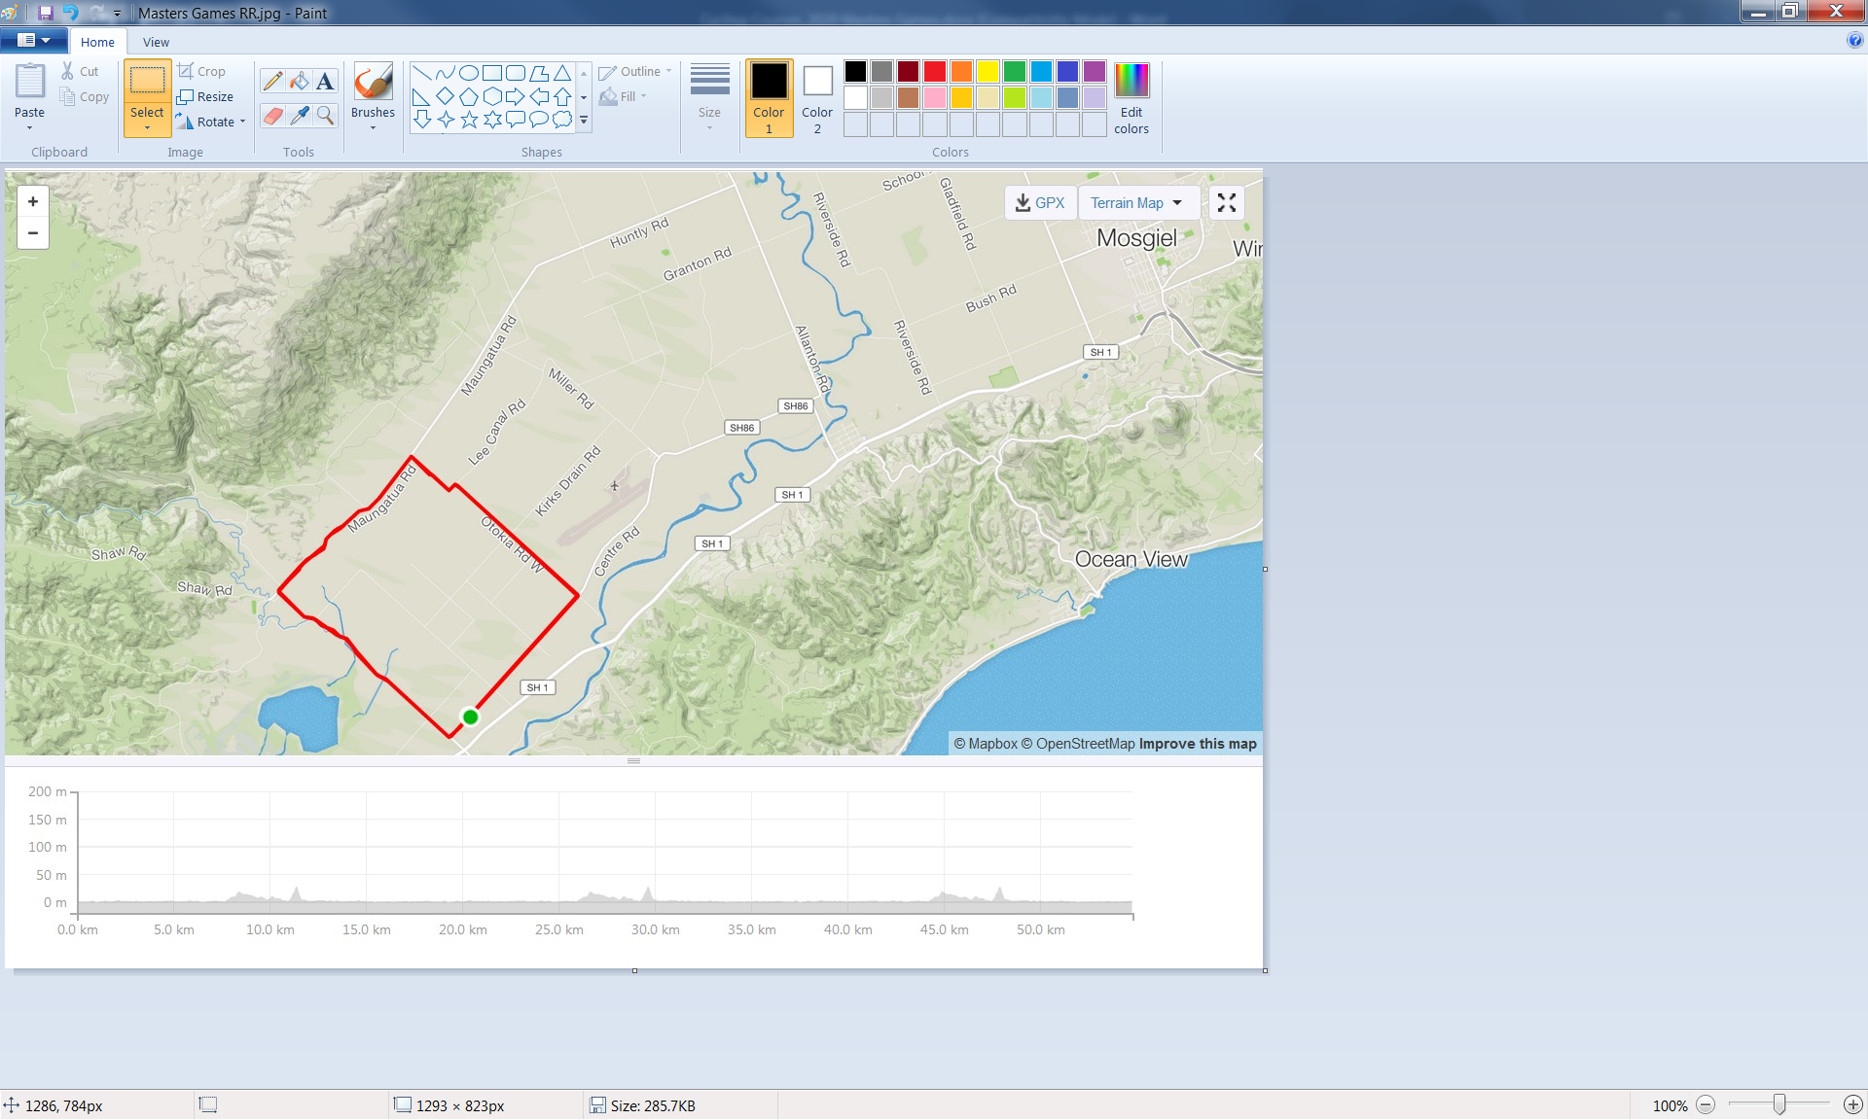

**For any queries contact:**

Paula Hasler 027 4731037

**Track Cycling – Monday 3rd February.**

Report to Cycling Otago Seddon Park Velodrome, Wickliffe Street, Mosgiel.

Registrations by 6.00 p.m. First race to commence at 6.30 p.m.

Programme will be Sprints, 500metre Time Trial, and Individual Pursuit.

At this stage there will be 10 year age groups, however if entries necessitate it, there will be 5 year age splits. Medal presentation will be approx.1 hour after the last race has finished.

**For any queries contact:**

Chris Ford 022 1958968